**Executive Summary**

The nature of spent nuclear fuel poses environmental and proliferation risks if not

properly handled. Due to current economic and political environment, spent nuclear fuel

is deposited in intermediate to long-term storage in lieu of reprocessing. In long-term

waste storage, spent nuclear fuel is stored indefinitely in remote geological repositories.

During the SNF’s time here, it is pertinent that the MPC’s contents are consistently verified to

determine if there has been any diversion of nuclear material. Our project plan aims to monitor these canisters to determine if there has been any diversion of one significant quantity of nuclear material with regards to the IAEA’s definition if one SQ of plutonium. The diversion of nuclear material in a repository canister will be monitored with a gamma ray detector. Information from the gamma detector will be available for remote monitoring. Decay heat from spent fuel assemblies will be harnessed to power the detector package by a means of a thermoelectric generator. Currently, the process for verifying the contents of a waste canister requires transfer to a containment pool for manual inspection. This process proves to be expensive and time consuming. Our MPC and remote monitoring system aim to reduce these costs and time investments by providing the IAEA with a continuity of knowledge (CoK) about the diversion status of the SNF stored in our MPC design through the transmission of the gamma ray detector signal and comparing later taken signals with the signal a fully stocked MPC to determine if diversion of one SQ has occurred over the SNFs time in storage.

**ACKNOWLEDGEMENTS**

We would like to thank our technical advisors, Dr. Sunil Chirayath and Karen Hogue, for their guidance and support throughout the course of this project.

Additional thanks to our friends and colleagues at Texas A&M University including Mohammad Otoom, Nolan McDonald, Kruk Mateusz, Ernesto____, (anyone else) for advice and assistance that they have provided us with.

Maybe thank Athena Specifically for her help with MCNP Design.

Praise Allah

**Nomenclature**

SNF Spent Nuclear Fuel

IAEA International Atomic Energy Commision

SQ Significant Quantity

**Introduction**

Nuclear power is a promising energy alternative with respect to prevalent fossil fuel options today due to its large energy density and cheap fuel costs. With increasing scientific evidence that fossil fuels carbon emissions can be attributed to climate change, nuclear energy’s zero carbon emissions energy production is especially attractive for future generations to come.

As nuclear power plants in the United States burn more fuel to reap these benefits of nuclear energy and provide for their consumers, more and more spent nuclear fuel is created only to be stored indefinitely or reprocessed. The U.S. nuclear waste technical review board projected by Dec 31st 2017 that there were 79,389 megatons of spent nuclear fuel in storage from U.S. PWR’s and BWR’s.

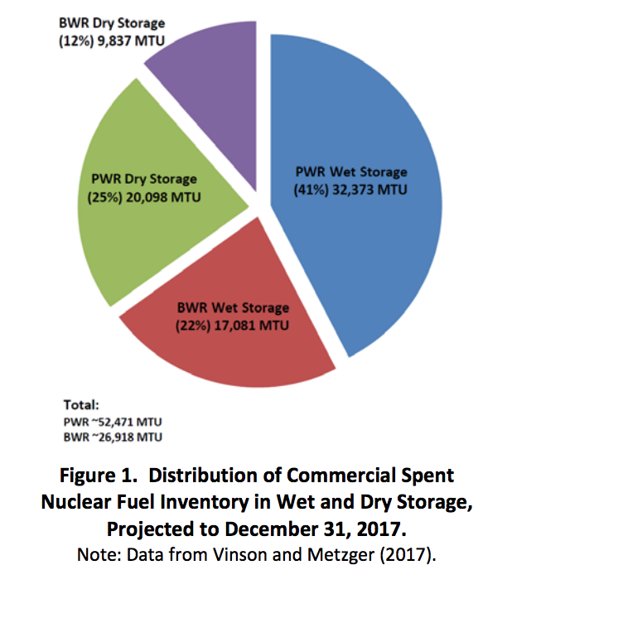

*(http://www.nwtrb.gov/docs/default-source/facts-sheets/Commercial_SNF.pdf)*

Spent nuclear fuel poses a proliferation risk because it is classified by the IAEA as “direct use material”, or nuclear material that does not require any further processing to make a nuclear weapon. The element of particular concern in spent nuclear fuel is plutonium due its fissile nature and the large (roughly 4kg) amount present in each fuel assembly. Roughly 8kg of plutonium is classified by the IAEA as one significant quantity. A significant quantity is defined by the IAEA as the approximate amount of nuclear material for which manufacturing a nuclear explosive is possible. This amounts to about two fuel assemblies. Information pertaining to the IAEA’s classification of significant quantities (SQ) of nuclear materials of interest are given below.

|  |  |
| --- | --- |
| Material | Significant Quantity (SQ) |
| Direct Use Nuclear Material | |
| Pu containing less than 80% Pu -238 | 8kg Pu |
| U-233 | 8kg U233 |
| HEU (U-235 > 20%) | 25kg U-235 |
| Indirect Use Nuclear Material | |
| LEU (U-235 < 20%) | 75 kg U-235 |
|  | 10 tons of natural U |
|  | 20 tons of depleted U |
| Thorium (TH) | 20 tons of Th |

(<https://www.iaea.org/sites/default/files/iaea_safeguards_glossary.pdf>) page 23 table 2

Preserving radioactive waste such as spent nuclear fuel in a safe and responsible manner presents a challenging issue to the long-term viability of nuclear energy. There are only two definitive methods for managing spent nuclear fuel in use today: reprocessing and direct fuel disposal. Due to the commercial delays in breeder reactor development, the high cost of fuel reprocessing and an international push for nonproliferation; many countries are considering long-term spent nuclear fuel repositories as a primary option. [1]Long-term spent nuclear fuel (SNF) storage has a definitive set of challenges associated with safeguards, security and safety. A geological repository presents a promising method for disposing large quantities of nuclear fuel. Existing and proposed repository sites are typically located in underground mines usually at depths varying from 400 to 1000 meters.[2] Spent nuclear fuel is stored in multipurpose metal canisters that are placed in a concrete overpack designed to contain the fuel’s radioactive contents for an indefinite period of time. A design of the multipurpose canister and the concrete overpack are shown below.

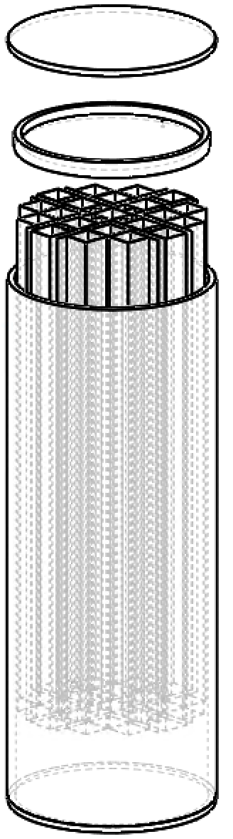

The overpack containing the multipurpose canister is sealed with a large metal concrete lid and stored on site on a concrete pad.

**[1]“Cost Analysis Methodology of Spent Fuel Storage,” TRD- 361, p. 1,**

**INTERNATIONAL ATOMIC ENERGY AGENCY, 1994. [online] Available:**

**http://www-pub.iaea.org/**

**[2]A. Nechaev, V. Onufrie, and K. T. Thomas, “Long-term storage and disposal of**

**spent fuel,” p. 19, INTERNATIONAL ATOMIC ENERGY AGENCY, spring 1986.**

**[online] Available: https://www.iaea.org/.**

**Spent Fuel Storage Today**

From a safety and safeguard standpoint, monitoring the contents of these storage containers is an important aspect of nuclear waste storage. Currently, there is not a system in place for determining container contents without physically opening the storage container. Having to open a storage container to verify the nuclear material inside is an expensive and time-consuming process. Power plants store their spent fuel in spent fuel pools where they spend roughly 5 years so that their fission products can decay away an appreciable amount to be stored on a dry cask pad. Here the fuel assemblies are transferred into a multi-purpose canister made of stainless steel and placed into a concrete overpack thats sealed shut. The SNF stays here for roughly 20 years until it is transferred to a geological repository or it stays there indefinitely if that is not an option.

**-talk about IAEA inspections of these sites regularly and when the overpack seal is broke**

**Project Overview**

The principal objective for any nuclear waste storage system is to minimize any radiological impact on the environment for an indefinite period of time. In the context of SNF repository containers, long term storage requirements include sufficient radiation shielding, a structural integrity design that can securely house the SNF indefinitely, and a strong resistance to environmental sources of degradation. Furthermore, a container design that provides the user with a continuity of knowledge (CoK) in regards to its contents will be a valuable tool for long-term content verification.

Interim dry storage of SNF canisters can remain dry storage facilities for a very long time as there are delays in fuel disposal methods, so storage sites can end up holding fuel past their initial life time of twenty years. There is a need for the remote monitoring of SNF storage canisters that will allow the IAEA a CoK of the SNF material in the canister.

There is currently a need to integrate non-destructive assay methods for the verification of SNF material in SNF storage. The goal of this project is to develop a long-term repository container that is able to provide a CoK to the end user while not sacrificing any of the current standards of current long term repository containers. The design should have a main focus to provide an additional safeguard against SNF diversion.

This goal will be achieved via implementation of a repository container detection system (RCDS) capable of autonomously monitoring the SNF, recording pertinent data, and transmitting that data to an external receiver for the appropriate analysis of the SNF inside of the canister, for the determination and verification that the diversion of a SQ of fuel has not been displaced or diverted from the SNF canister

A repository cask design that provides the user with a CoK will expedite the assessment process of the storage container, allowing for a large reduction in inspection cost and time without compromising the structural integrity of the canister or resulting in the costly, and time consuming, destructive assay of the SNF canister. The implementation of this remote monitoring system will provide the IAEA with a routine, and reliable, close monitoring of repository containers to determine if diversion of nuclear material has occurred.

It is possible that in the future, there will be a greater interest in reprocessing SNF stored in long-term geological repositories. In this scenario, a verification of fuel stored within storage canisters is required. If there is a desire to open a storage container for fuel reprocessing purposes, the user may wish to verify the container is full of spent fuel assemblies before having the container physically opened.

Providing the International Atomic Energy Agency (IAEA) safeguard inspectors with a continuity of knowledge (CoK) of radioactive waste from end of irradiation (EOI) and throughout final repository may allow for a confident determination of storage container contents.

**Objectives**

Our objective for our multi purpose canister design and remote monitoring system will be to ensure the safe containment of radioactive material for an indefinite period. This is essential to any successful long-term high level waste storage container. The principal objective is to design a repository cask that incorporates these design standards with a method that establishes a continuity of knowledge (CoK) in regards to the radioactive materials stored within the canister.

**Executive Summary**

The nature of spent nuclear fuel poses environmental and proliferation risks if not

properly handled. Due to current economic and political environment, spent nuclear fuel

is deposited in intermediate to long-term storage in lieu of reprocessing. In long-term

waste storage, spent nuclear fuel is stored indefinitely in remote geological repositories.

During the SNF’s time here, it is pertinent that the MPC’s contents are consistently verified to

determine if there has been any diversion of nuclear material. Our project plan aims to monitor these canisters to determine if there has been any diversion of one significant quantity of nuclear material with regards to the IAEA’s definition if one SQ of plutonium. The diversion of nuclear material in a repository canister will be monitored with a gamma ray detector. Information from the gamma detector will be available for remote monitoring. Decay heat from spent fuel assemblies will be harnessed to power the detector package by a means of a thermoelectric generator. Currently, the process for verifying the contents of a waste canister requires transfer to a containment pool for manual inspection. This process proves to be expensive and time consuming. Our MPC and remote monitoring system aim to reduce these costs and time investments by providing the IAEA with a continuity of knowledge (CoK) about the diversion status of the SNF stored in our MPC design through the transmission of the gamma ray detector signal and comparing later taken signals with the signal a fully stocked MPC to determine if diversion of one SQ has occurred over the SNFs time in storage.

**Detector Package and Technology:**

Current spent nuclear fuel canisters merely act as a structurally sound vessel to contain spent nuclear fuel for an indefinite period of time. These fuel canisters do not currently have a system in place for the verification of the SNF inside the canisters without breaking the seal of the canister resulting in the destructive assay and verification of the material inside. This project had a goal in mind to provide a system that would be able to transmit canister count data via wireless transmission that would be able to provide a verification of the contents of the SNF canister. To accomplish this goal, a detector package consisting of 2 polyvinyl toluene scintillation detectors, a rechargeable canister battery, and a wireless transmitter were implemented to provide the user with gamma count information to verify that the diversion of SNF had not occurred over the lifetime of the canister.

**Overall Design Aspects:**

The detector package will operate on the power provided by the ETG inside of the spent fuel canister and will work in conjunction with a wireless transmitter that will transmit data collected inside of the spent fuel canister to a receiver on the outside of the canister that will further be able to transmit the data remotely. To plan for the event of a potential ETG failure in powering the detector, a canister battery was implemented as a redundancy that would be charged by the ETG power during its operation, and could be used to power the detector for a limited time if the ETG were to fail.

**Detection of Diversion Method:**

To provide a continuity of knowledge of the SNF inside of the MPC, a method was needed in order to detect whether or not fuel had been removed from the SNF canister. To detect diversion, a gamma detector was chosen in order to take counts over the lifetime of the canister. A gamma detector was chosen because throughout the 55-year life time of the canister, cesium-137 has a half-life of 30.7 years, so there was an assurance that a large quantity of gamma emitting nuclides would be present throughout the lifetime of the repository canister. Having knowledge of the activity of the radioactive nuclides inside of the spent fuel would provide an accurate representation of the expected number of gammas that would be emitted from the radionuclides. This would allow for an analysis on whether or not diversion had occurred by detecting a change in the count rate of incident photons on a gamma detector as the photon counts of cesium-137 would decrease due to the removal of two fuel assemblies (2 SQ’s worth) of SNF.

Several constraints on the design of the SNF detector package had to be considered for the design of the detector package. Since the detector package is going to be inserted into the canister when the fuel is inserted, and the canister is sealed, the detector package had to be ready to be operational for a long period of time. Since the goal of implementing this design to maintain a CoK of the contents of the SNF canisters, the detector package also had a constraint that it would not be able to have maintenance on it for the duration of the lifetime of the canister, so in choosing a design for the detector material, the material needed to be durable and be able to function within the isolation of the canister. Since the spent fuel will obviously be decaying within the canister, the detector would be subjected to large amounts of radiation, so the detector material would need to have an inherent resistance to the effects of radiation on the scintillating material.

A NaI scintillator detector was thought to be the optimal choice because of its ideal gamma detecting and spectral analysis capabilities, but because of the environment of the SNF canister environment, the cost of NaI crystal, the size required for the NaI crystal itself, and how fragile the NaI crystal is, it was determined that sodium iodide scintillation would not be suitable enough for the lifetime of the SNF canister. As a result, it was necessary to select a polyvinyl toluene (PVT) plastic scintillation detector to accomplish this by routinely taking detector counts quarterly throughout the year to determine whether or not spent fuel was removed from the canister.

There are several benefits to utilizing a plastic PVT detector for the design of the detector package in the spent fuel canister. PVT is cheaper to fabricate and is much more durable than NaI scintillation crystals, and it is also easy to fabricate into a variety of different shapes and sizes. In the context of being fit to be used in the spent fuel canister, the organic plastic scintillation crystal was an optimal choice because of its durability in the high temperature environment of the spent fuel canister as well as being very durable and resistant to radiation hardening and radiation damage []. Plastic scintillator detectors are also great for continuous monitoring scenarios and are used in high energy particle physics for this reason, meaning that they can be used for a large range of energies and for a long time which is optimal for our canister design. PVT detectors are also capable of detecting gamma energies greater than 100 keV, and since cesium-137 will be the most prevalent gamma emitter over the lifetime of the MPC, and has gamma emission energy of 662 keV, the PVT detector will be able to detect the gamma energies being emitted by the decaying nuclides.

|  |  |  |  |  |
| --- | --- | --- | --- | --- |
| PVT Material |  |  |  |  |
| BC-400 |  |  |  |  |
| BC-412 |  |  |  |  |
| BC-444 |  |  |  |  |

There are also several limitations to utilizing a PVT detector. They do not yield a photopeak above 60 keV energy gammas, so this makes it ineffective for the identification of gamma emitting nuclides. It has a very low detector efficiency in comparison to NaI at the same energies and has approximately 15% of the detector efficiency of NaI. These factors limited the design and instrumentation of the detector, but it was initially determined that they would not limit the proposed detection of diversion because it would not inhibit the detectors ability to establish a threshold for the expected number of photon interactions on the scintillating material. In the event this threshold was altered, the number of photon interactions, and therefore counts would decrease, and this would indicate diversion had occurred. This made it unnecessary for the identification of nuclides within the canister as long as this change in interactions/counts could be tracked.

**-This is space where I put a table of different PVT’s and discuss the selection**

The main focus on the detector was how it would be able to provide relevant information to determine whether diversion of fuel had occurred inside the fuel canister. The method that was chosen was that it would nee

**Wireless Data Transmission:**

The wireless data transmission of the data obtained by the PVT detector inside the MPC proved to be a challenging issue. The canister is sealed early on when the detector package is inserted with the fuel assemblies, and because of the radioactive nature of the canister it is designed to be leak proof to contain the emission of radiation. This means that no holes could be drilled in and out of the canister to provide power to the detector components or a cable to transmit data. Transmitting wireless data through metal barriers cannot be accomplished in conventional ways due to the shielding effect of metal, so the typical method of transmitting data electromagnetically would not be appropriate for the CoK design for the canister due to the canister being composed of stainless steel. Ultrasonic data transmission is currently a newer and upcoming solution to this issue as ultrasonic waves are more efficient and can propagate easily through different kinds of metal material []. It was decided that the complete design of an ultrasonic wireless transmitter was beyond the scope of this project, but its capabilities, power consumption, and process of data transmission could still be explored.

*The theoretical process for the wireless transmission of data involves converting the computer inputs into a binary code that could be outputted to the ultrasound device. From there, the binary inputs would then be translated into two separate sound waves representing a 1 or a 0. The sound waves would then be received by a receiver on the outside of the canister, and its data would be translated back to binary to be sent to an external user.*

The innovation of the current SNF canister design revolves around the continuity of knowledge of the material in the canister. It was decided that in order for the canister to have the highest functionality, it would need to be able to send several different kinds of data to a remote user for them to understand what the current condition the canister was in, and to transmit count data to the user. Below is a simple code developed in python that would be read from a small input/output computer inside of the canister. It was decided that the canister should transmit data pertinent to:

-Detector Count Data

-Functionality of the ETG

-ETG Power Output

-Canister Battery Charge

-Battery Capacity

This would allow the outside user with information that would indicate the current condition that the detector package was currently in. The important thing about this transfer of communication would allow for action to be taken in the event of RTG failure. It would allow for the knowledge that the redundant battery pack was now powering the operation of the canister detection package, and would allow for the inspection of the canister to ensure that further redundant security and safety measures could be taken to ensure that the canister material had not been diverted.

*Radiation Part*

**Assembly Modeling in MCNP**

MCNP or Monte Carlo N-Particle code developed by Los Alamos national laboratory allows for particle simulations and transport modeling with neutrons photons and electrons. It was used to generate the source term for a Westinghouse 17x17 PWR 3.6% enriched fuel assembly with a burnup of (~~~~~~~~)MWd/Mt. The multi purpose canister model was also used MCNP to simulate the detector response to assembly presence and diversion.

-how do i justify all the same assemblies for all positions

**Getting a 17x17 burnt /decayed Assembly model source term**

The multipurpose dry cask canister source term was computed with MCNP in a couple of steps. Initially, a 17x17 3.6% enriched UO2 input deck was burned for 5 years to get a model of an assembly that is coming right out of a fuel cycle at a power plant. The resulting isotopics from this burn are then placed in that same 17x17 assembly’s material cards section to model a burnt assembly put through 50 years of decay with steps of 5 years, 25 years and 50 years. The isotopics in these decay steps are the isotopics present in the MPC during the fuel assembly’s lifetime in storage. These timesteps are shown below in Table X.

-inlucde timestep table

The isotpics of interest are those at the 25 year timestep after the assemblies have finished their storage time on the dry pad and enter the geological repository. PYTHON was used to sort through the MCNP decay output to determine which isotopes present contributed to greater than 1% of the total activity of all isotopes present. This delimiting was done to simplify the problem under the assumption that any activity less than 1% of the total activity present from all isotopes is negligible. The isotopes of interest are shown below. Included in Appendix [] are the beginning of storage life and end of monitoring life activity information.

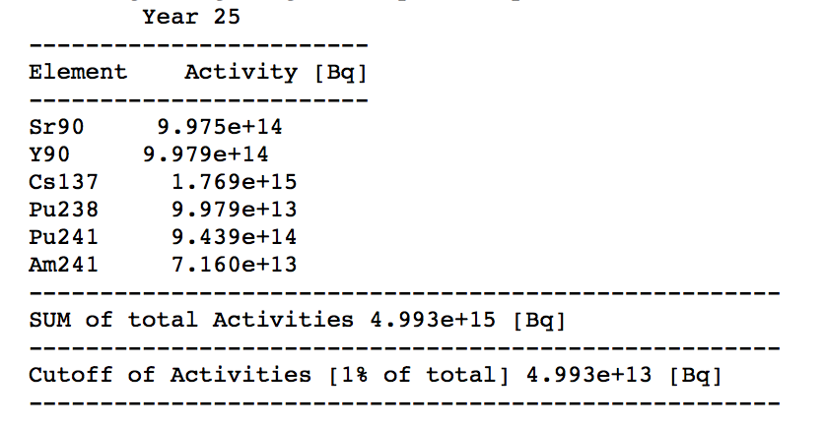

**Source Term Spectrum**

The decayed 17x17 assembly deck’s isotopes of interest were sorted with a PYTHON nuclear data module called PYNE. This module calls on ENDSF nuclear data and allows for the determination of which isotopes present are gamma emitters among other things. This module also allowed for the determination of the gamma emitters branching ratios and energies allowing for a gamma ray spectrum to be put together along with the source term containing gammas per second at a particular branching ratio and energy. The spectrum was put together to get a visual representation that the most active isotope after 50 years was Cs137 which is a result of its long half life of 30.2 years. Included in Appendix [] are the beginning of storage life and end of monitoring life gamma spectrums.

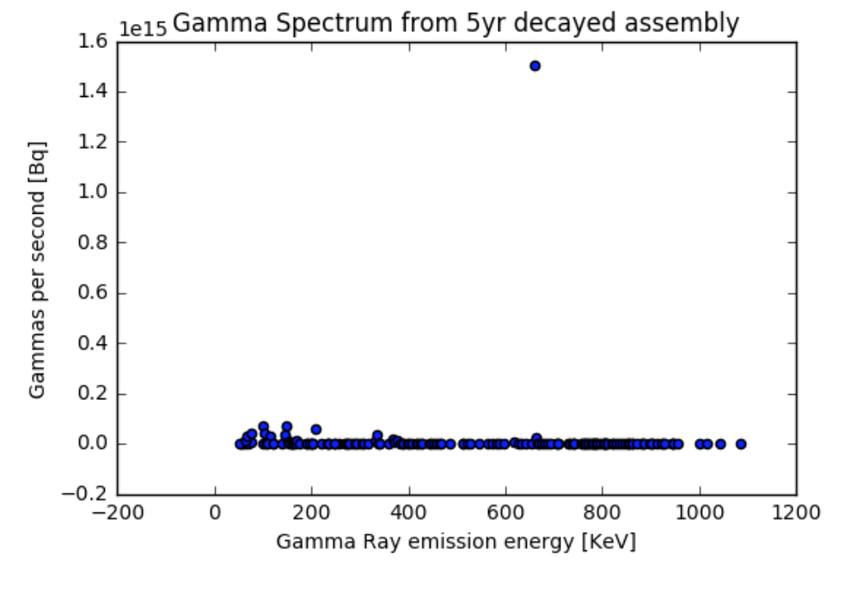

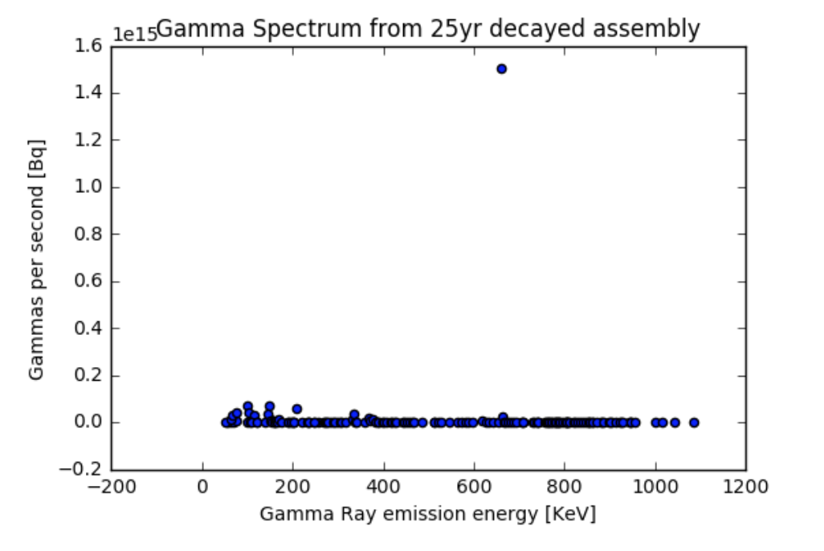

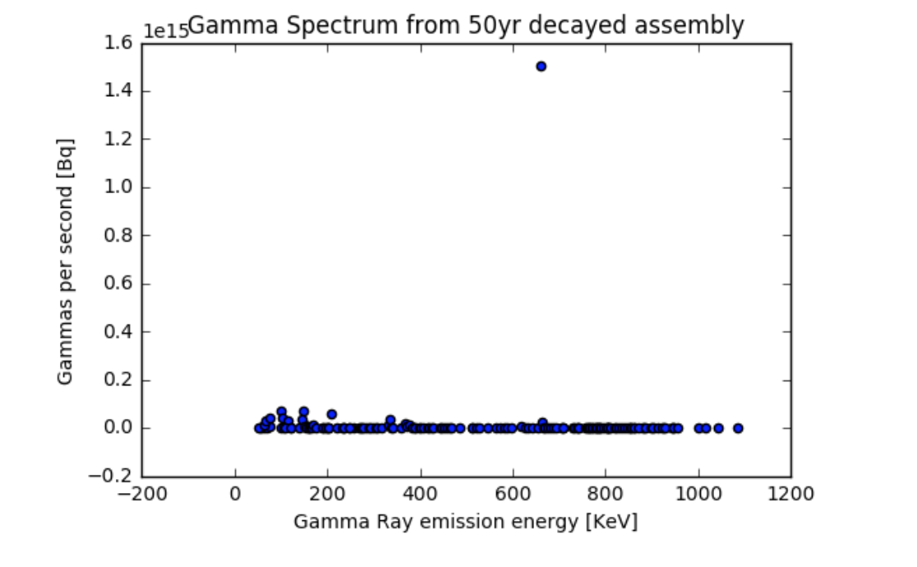

**Dry cask and Multi-Purpose Canister (MPC) model**

The MCNP model of the MPC is based off of the NRC’s CASTOR V21 design. This design was meant to be given to the nuclear power plants in the U.S. but never ended up becoming a reality because they were never handed out by the NRC. (requires citation) Our final cask design is a mix between the CASTOR V21 and the Transportation Aging and Disposal design (TAD). The reasoning behind this was to simplify the MCNP and STAR CCM modeling by taking out the CASTOR V21’s spacing between assemblies and using the spacing in the TAD model. The 21 assembly positions from the CASTOR V21 design was used to model a design that was proposed to be implemented in large scale in the U.S. (requires citation) The CASTOR V21 and TAD MPC designs are shown below.

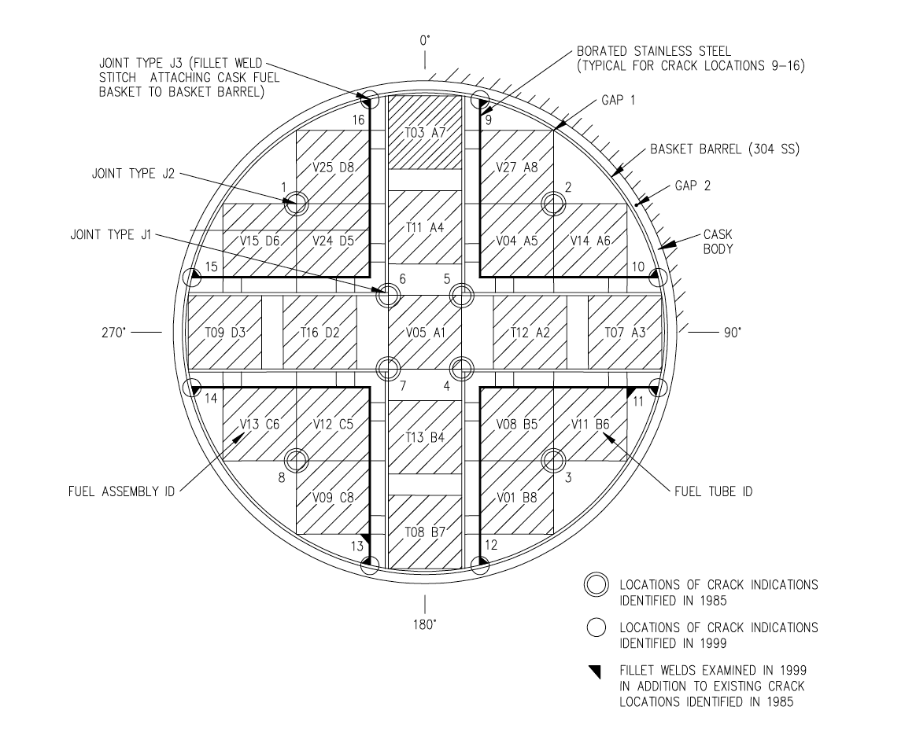

(still need TAD design MPC picture from nick)

(still need MCNP MPC layout picture)

-state how deck is layed out, what it contains

-include picture of MPC cask layout in the concrete overpack

**-**include MCNP dimensions?

**Inputting Source Term**

This source term consisting of gammas per second, branching ratios, and energies was put into an MCNP dry cask model deck in a 21 position formation with the assembly’s lined with Boral to isolate them neutronically. There are two cylindrical Sodium Iodide detectors positioned on top of the MPC lid with an F4 flux tally which determine the gamma response during the assembly’s time in storage. A diversion from the cask will result in a lower gammas per second count that can be analyzed by comparing a diversion gamma count rate case with a full MPC gamma count rate case.

The sodium iodide detector response was multiplied by a factor to convert it to a PVT detector response to match our detector choice. This method was chosen because we wanted to explore both detector choices and choose which would be the best at detecting diversion without having to run the same cases over again in MCNP with a PVT detector.

-include D0 case pic

-include side view of canister

**Diverting Fuel Assemblies**

There were 7 diversion cases carried out in the top left quadrant of the MPC containment that were determined to have the largest change in detector response with respect to closer diversion cases. If these diversion cases can be detected with positions far from the detector, then closer diversion positions will be able to be detected without any trouble. Diversion cases of either one or two assemblies were considered as it would be less efficient for a nefarious third party to divert single fuel pins containing much less direct use nuclear material than a whole assembly. 6 of these diversion cases are considered to be symmetric about the middle row and middle column of the MPC containment. A diversion of position 4 for example would yield the same detector response as a diversion from position 8. This is due to their equal distance from the detectors and the isotropic emission of the sources distributed in the MPC positions. This symmetry is shown below in Figure X.

-include a pic of symmetric positions

In these symmetric cases, a diversion from the left quadrants would yield a larger left detector response than the right detector. The symmetric position in the right quadrant would respectively have a larger right detector response than the left detector. The 6 symmetric diversion positions are shown below.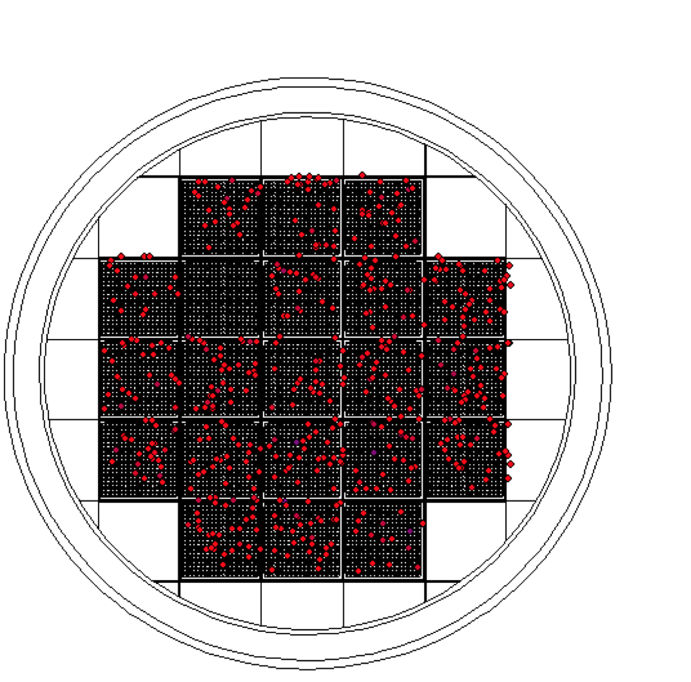

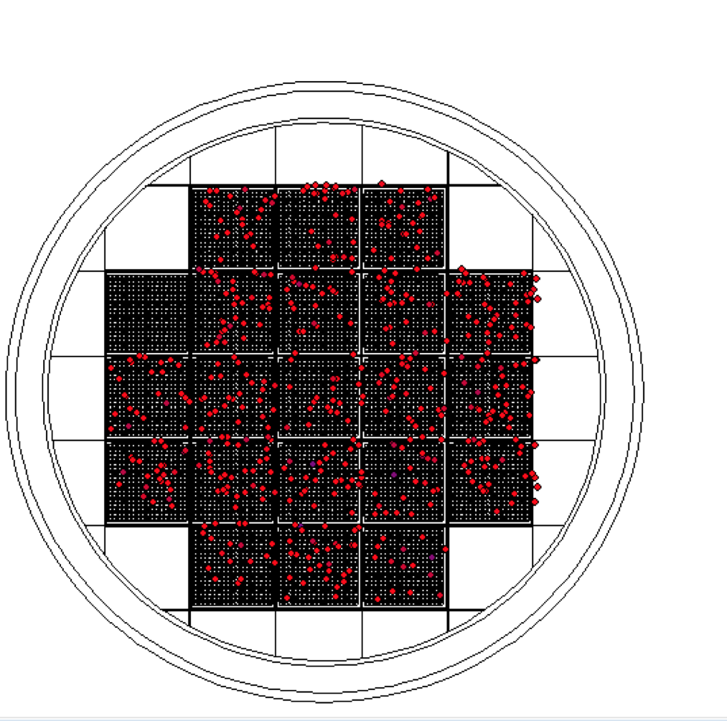

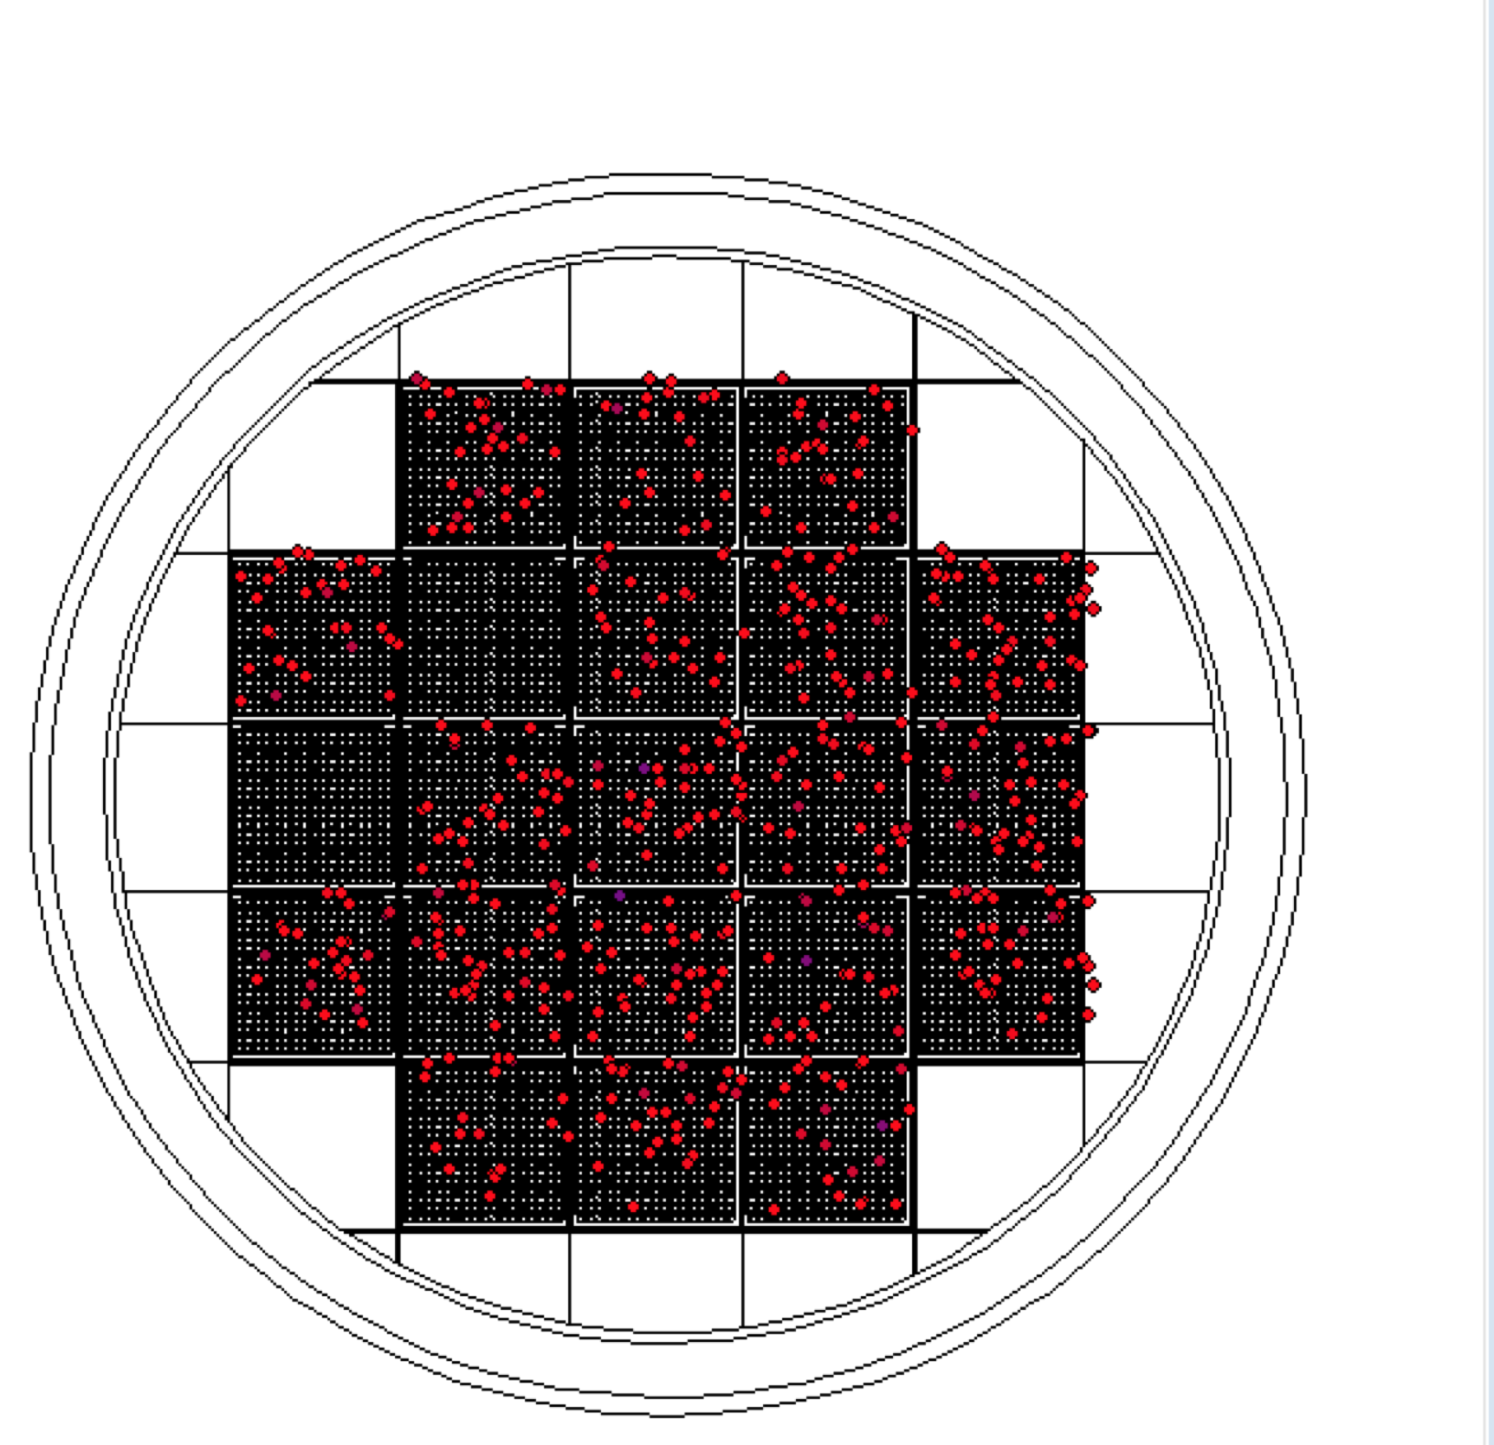

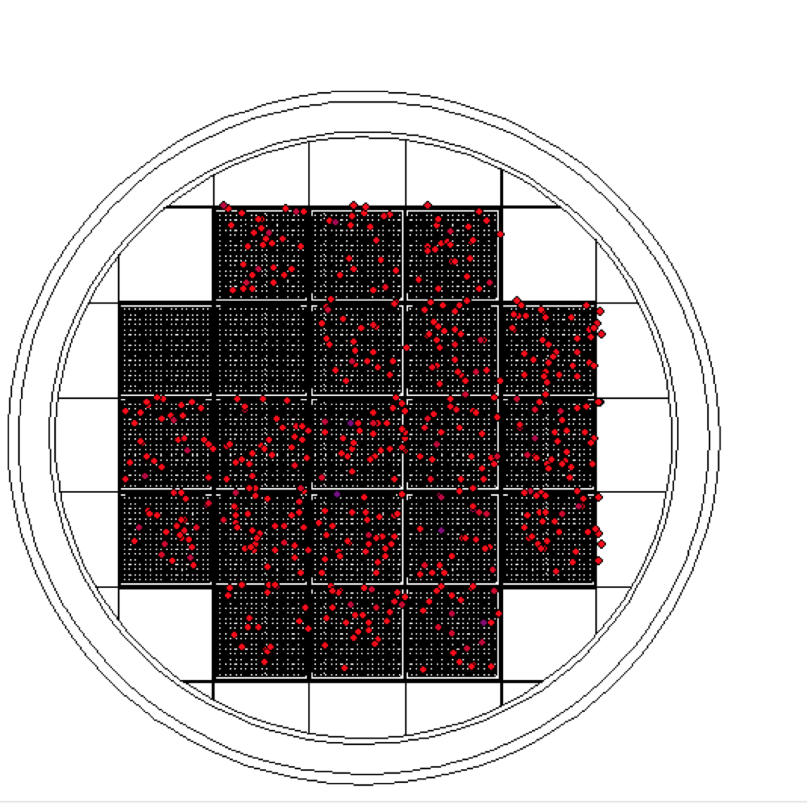

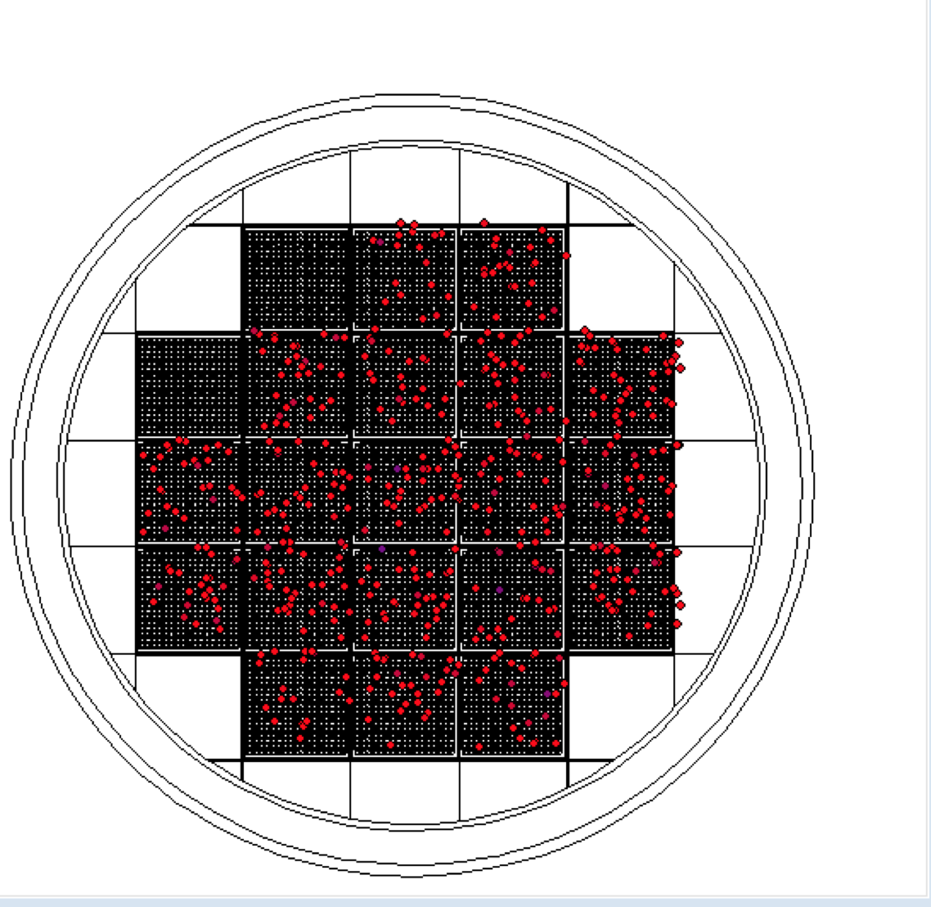

-(include diversion maps)

**Making Sense of the Detector F4 Tally**

The F4 tally tracks the particle flux within a cell. This tally multiplied by the source term to gives the gamma rays per second per cm^2 passing through that volume. This tally value also contains an associated error. The MCNP cases ran were with a sodium iodide detector. A base case with a PVT detector was run to get a sodium iodide to PVT factor to convert the sodium iodide detector cases to PVT detector cases. Along with the associated error given by the MCNP model, there is also an associated error of the actual detector. The true error equation is given below.

**Checking validity of deck with analytical computation?**

**Spent Nuclear Fuel Analysis Procedure**

As defined by the IAEA, a significant quantity of direct us nuclear material is 8kg of plutonium with a Pu238 content less than 80%. In order to detect one significant quantity of direct use material, it is required that the diversion of two spent fuel assemblies, or 1.37 significant quantities can be detected by a remote monitoring system. The case of the diversion of single fuel pins is considered nonexistent due to the unequal amount of effort with respect to significant quantities diverted by a nefarious third party.

The diversion analysis was conducted to determine if one significant quantity of diverted SNF from the MPC could be detected by the detectors. For each diversion case, the number of assemblies present in the MPC was multiplied by the source term for one assembly to get the total source term for that diversion scenario. The summary of each diversion case is given below.

|  |  |  |  |
| --- | --- | --- | --- |
| Diversion case | Number of assemblies diverted | Ammount of Plutonium diverted (kg) [SQ] | Diversion corrected source term [Bq] |
| D4 | 1 | 5.5 [0.687] | 4.16E+16 |
| D5 | 1 | 5.5 [0.687] | 4.16E+16 |
| D9 | 1 | 5.5 [0.687] | 4.16E+16 |
| D1 and 4 | 2 | 11.00 [1.37] | 3.95E+16 |
| D4 and 5 | 2 | 11.00 [1.37] | 3.95E+16 |
| D5 and 9 | 2 | 11.00 [1.37] | 3.95E+16 |

After the diversion and reference cases were run their gaussian distributions were plotted with the cases respective means and standard deviations. For the reference case of 21 assemblies in the MPC, a false detection probability (alpha) was set as a threshold and detection probabilities (beta) were computed for each diversion case. False detection probability is defined by the IAEA as an “analysis of accountancy verification data would indicate that an amount of nuclear material is missing when, in fact, no diversion has occurred...” A false detection is undesirable because it would require the IAEA to visit the site only to find diversion has not occurred thus wasting their time and money and render our design a failure as it is meant to facilitate remote monitoring of the MPC. This value is usually set at 5% so that the detection probability (1-beta) is between 95-100%.

**Diversion Analysis with photon radiation signal**

The selected design for the multipurpose canister was to place two PVT detectors on top of the canister to monitor gamma ray emission count rates quarterly. The detectors will take a gamma count of the spent fuel assemblies gamma ray emissions upon initial loading into the canister to establish a 5% non detection probability. Any mean count rate taken upon subsequent quarters greater than this 5% threshold will be considered undetectable to establish a high detection probability of 95-100%.